COMP517 – Data Analysis
Assignment 1: Data Exploration and Analysis

Full Name: [Full Name]
Student ID: [Student ID]
Date: 11 September 2026
Dataset chosen: Global Air Quality 2023 (Messy)

Table of Contents
Right-click and choose 'Update Field' in Word to generate the Table of Contents.

List of Figures
Figure 1: Boxplots of Pollutant Concentrations (Outlier Detection)
Figure 2: PM2.5: Outliers vs Non-Outliers (IQR method)
Figure 3: PM10: Outliers vs Non-Outliers (IQR method)
Figure 4: Distributions of the Nine Numeric Variables (Histograms)
Figure 5: Top 10 Countries by Number of Air Quality Records
Figure 6: Share of Records by Calendar Quarter
Figure 7: Boxplots of Weather Variables
Figure 8: Correlation Heatmap of Pollutant and Weather Variables
Figure 9: Record Count by Country (Top 5) and Calendar Quarter
Figure 10: Mean vs Median PM2.5 by Country
Figure 11: Air Quality Risk Score by Temperature Band

List of Tables
Table 1: Data Dictionary for the Global Air Quality 2023 Dataset
Table 2: Missing Values by Column and Imputation Method Used
Table 3: Outlier Detection Bounds and Counts (IQR Method)
Table 4: Summary Statistics for Numeric Variables (Cleaned Dataset)
Table 5: Mean and Median PM2.5 by Country (Top 10 by Record Volume)
Table 6: Air Quality Risk Score by Temperature Band

1. Introduction & Dataset Summary
This report presents a full exploratory data analysis (EDA) of the “Global Air Quality 2023 (Messy)” dataset, undertaken to satisfy COMP517 Assignment 1. The purpose of the report is to demonstrate the practical skills required to load, clean, explore and interpret a small-to-medium scale, real-world-style dataset (Course Learning Outcome LO1), and to communicate the resulting findings clearly and accurately (LO2). All code used to produce the results, tables and figures referenced in this report is contained in the separate accompanying Python file, air_quality_eda.py, and is not reproduced here.

1.1 Dataset Overview
- The dataset is a deliberately “messy” version of the Global Air Quality Dataset originally published on Kaggle by WAQI786, modified by Coffxc12/Alish Dahal to include injected missing values, duplicated rows, noisy/outlier values, and inconsistent text formatting, specifically to give practice with data-cleaning techniques.
- Before cleaning, the dataset contains 30,450 rows and 12 columns.
- Each row represents one air-quality reading for a given city, country and date during the 2023 calendar year, covering 20 cities across 19 countries.
- The 12 columns are: City, Country, Date, six pollutant concentration measures (PM2.5, PM10, NO2, SO2, CO, O3) and three weather measures (Temperature, Humidity, Wind Speed). A full data dictionary is given in Table 1.
Table 1: Data Dictionary for the Global Air Quality 2023 Dataset
Column | Type | Description
City | Text | City where the reading was recorded (20 unique cities after cleaning).
Country | Text | Country the city belongs to (19 unique countries).
Date | Date | Date the reading was taken (1 Jan – 28 Dec 2023).
PM2.5 | Numeric | Fine particulate matter concentration (diameter < 2.5 µm).
PM10 | Numeric | Coarse particulate matter concentration (diameter < 10 µm).
NO2 | Numeric | Nitrogen dioxide concentration.
SO2 | Numeric | Sulphur dioxide concentration.
CO | Numeric | Carbon monoxide concentration.
O3 | Numeric | Ground-level ozone concentration.
Temperature | Numeric | Ambient air temperature (°C).
Humidity | Numeric | Relative humidity (%).
Wind Speed | Numeric | Wind speed at the reading location.

1.2 Data Types and Structure
- City, Country and Date were stored as text (object) columns; the remaining nine columns (six pollutants, three weather variables) were stored as numeric (float64) columns.
- The Date column required conversion from text to a proper datetime type. The format was confirmed as M/D/YYYY — values such as “10/27/2023” rule out a D/M/YYYY interpretation, since there is no 27th month — and every one of the 30,450 date values parsed successfully under this format.
- City and Country required text-casing and whitespace normalisation before they could be used reliably as categorical fields (see Section 2 for detail); no column had an incorrect fundamental data type.

1.3 Initial Summary Statistics
- df.describe() on the raw data showed all six pollutant columns already bounded within realistic, fixed ranges (e.g. PM2.5 5.02–149.98, Humidity 10.01–99.99%), with means and medians very close together — an early sign of near-symmetric distributions confirmed later in Section 3.
- df.isnull().sum() showed missingness confined entirely to the six pollutant columns, each missing between 4.84% and 5.25% of values; City, Country, Date and the three weather columns had zero missing values (see Table 2 in Section 2.1).

2. Data Pre-processing
This section reports every pre-processing decision made, and the justification behind it, before any exploration or analysis was carried out on the dataset.

2.1 Missing Values
- Only the six pollutant columns had missing values: PM2.5 (1,552, 5.10%), PM10 (1,561, 5.13%), NO2 (1,593, 5.23%), SO2 (1,475, 4.84%), CO (1,496, 4.91%) and O3 (1,600, 5.25%). See Table 2.
- Rather than assuming a fixed rule (e.g. “median for pollutants”), the skewness of each column was calculated first. All six pollutant columns returned a skew between −0.02 and 0.02 — essentially perfectly symmetric — so mean imputation was used for every pollutant column, since mean imputation is the statistically appropriate choice for symmetric data and median is only preferred when a distribution is skewed.
- The mean used was each column's mean calculated separately within each Country group, not a single dataset-wide mean. An earlier version of this analysis used one global mean, but that repeated a single fixed value across every country's rows and was found to distort the per-country comparison in Section 4.3 (every country's median collapsed to the same imputed number). Imputing within each country's own values avoids injecting a foreign, cross-country constant into a column that is later compared *between* countries.
- No rows or columns were dropped, since the proportion of missing data in any single column never exceeded 5.25%, well below the 5–10% threshold at which removal would typically be considered over imputation.
Table 2: Missing Values by Column and Imputation Method Used
Column | Missing Count | Missing % | Method Used
PM2.5 | 1,552 | 5.10% | Per-country mean imputation
PM10 | 1,561 | 5.13% | Per-country mean imputation
NO2 | 1,593 | 5.23% | Per-country mean imputation
SO2 | 1,475 | 4.84% | Per-country mean imputation
CO | 1,496 | 4.91% | Per-country mean imputation
O3 | 1,600 | 5.25% | Per-country mean imputation
City / Country / Date / Temperature / Humidity / Wind Speed | 0 | 0.00% | None needed

2.2 Duplicate Records
- 13,897 of the 30,450 rows (45.64%) were exact duplicates — every one of the 12 columns identical — consistent with the dataset's documentation stating duplicated and near-duplicate rows had been deliberately injected.
- A wider check on rows sharing only the same City, Country and Date (a natural composite key for this dataset) found 25,375 matching rows (83.3%) — far more than the exact-duplicate count. This means roughly 11,478 rows share a city and date with another row but report different pollutant or weather readings.
- Decision: only the 13,897 exact duplicates were removed with drop_duplicates(), leaving 16,553 rows. Rows that merely shared a City+Country+Date key but differed in their measurements were kept, because a city could legitimately have multiple monitoring stations or repeat readings on the same day, and the dataset provides no finer-grained timestamp or station ID to arbitrate between them. Removing them on suspicion alone risked discarding genuine measurements.
- This ambiguity is acknowledged as a limitation of the dataset and is revisited in the Conclusion (Section 5.2).

2.3 Outlier Detection and Treatment
- The Interquartile Range (IQR) method (flagging values below Q1 − 1.5×IQR or above Q3 + 1.5×IQR) was applied to all nine numeric columns on the de-duplicated data. Table 3 gives the exact bounds used for each column.
- Result: zero outliers were detected in every single numeric column. This was cross-checked on PM2.5 using the z-score method (|z| > 3), which also returned zero outliers.
- Investigating why: the minimum and maximum of every pollutant and weather column sit at suspiciously round, fixed values (e.g. PM2.5 ranges exactly 5.02–149.98, Humidity exactly 10.01–99.99%, Wind Speed exactly 0.5–20). This indicates the underlying values were generated or clipped within fixed bounds rather than drawn from a distribution with a genuine long tail. For data generated this way, the IQR bounds computed from the (wide, near-uniform) middle 50% of the data extend beyond the data's actual minimum and maximum, so no point is ever mathematically flagged — even though the dataset's own documentation describes injecting “noisy/outlier AQI values.”
- Decision: since no genuine statistical outliers were found by either method, no values were removed or transformed on outlier grounds. This null result is itself reported as a meaningful finding rather than assumed away.
- A physically-impossible-value check was also run (Humidity outside 0–100%, negative Wind Speed): zero rows were removed, confirming the weather columns are already within valid physical ranges.
Table 3: Outlier Detection Bounds and Counts (IQR Method)
Column | Lower Bound | Upper Bound | Outliers Found
PM2.5 | -53.02 | 208.31 | 0
PM10 | -67.83 | 276.97 | 0
NO2 | -33.45 | 136.84 | 0
SO2 | -18.61 | 69.20 | 0
CO | -3.98 | 13.98 | 0
O3 | -67.58 | 277.94 | 0
Temperature | -35.41 | 65.07 | 0
Humidity | -35.04 | 144.37 | 0
Wind Speed | -9.19 | 29.66 | 0

2.4 Outlier Visualisation
Figures 2 and 3 plot every PM2.5 and PM10 reading respectively, coloured by whether the IQR method classified it as an outlier or not. As expected from Table 3, every point in both plots is classified as a non-outlier. Both scatterplots show a clearly visible horizontal band of points around 75–80 for PM2.5 — this is the approximately 844 imputed points (from the 1,552 originally imputed in Section 2.1) that survived de-duplication, now visible as an artificial cluster rather than a genuine reading. Because imputation is done per-country (Section 2.1) rather than with one shared number, this cluster is a *tight band* of ~19 slightly different country-mean values rather than a single exact line — visible proof that the fix in Section 2.1 changed the underlying values, even though the countries' PM2.5 means happen to be close enough together (75.5–80.2, see Table 5) that the band still looks like one line at this scale. Figure 1 (boxplots of all six pollutants) confirms the outlier result: no whisker points extend beyond the box in any pollutant.
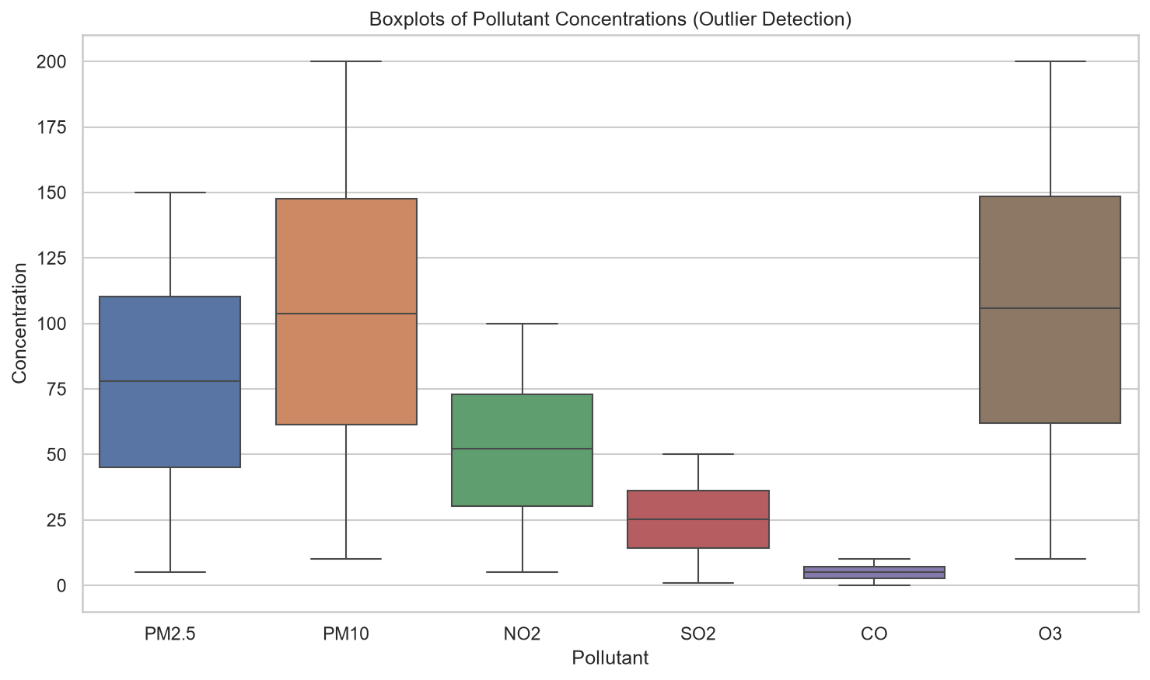
Figure 1: Boxplots of Pollutant Concentrations (Outlier Detection)
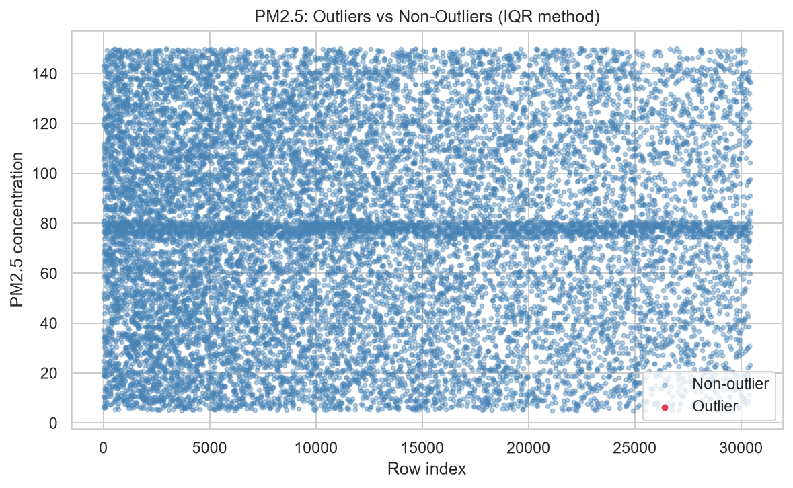
Figure 2: PM2.5: Outliers vs Non-Outliers (IQR method)
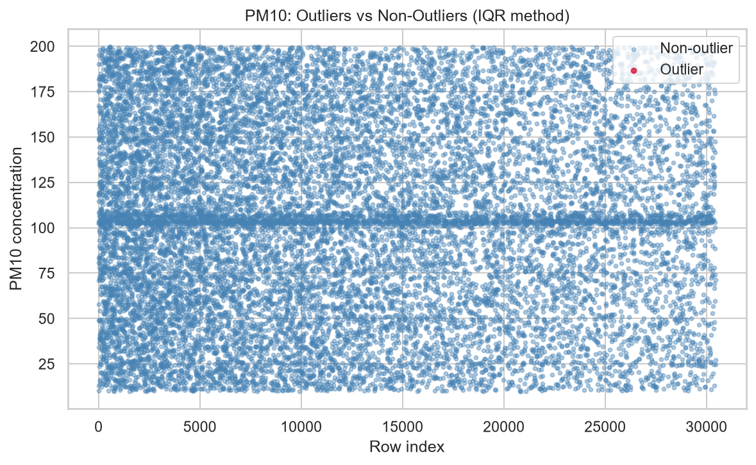
Figure 3: PM10: Outliers vs Non-Outliers (IQR method)

3. Data Exploration and Visualisation
This section explores the cleaned, de-duplicated dataset (16,553 rows) using summary statistics and a range of univariate visualisations.

3.1 Summary Statistics
Table 4: Summary Statistics for Numeric Variables (Cleaned Dataset)
Variable | Mean | Median | Std Dev | Min | Max
PM2.5 | 77.79 | 78.12 | 40.07 | 5.02 | 149.98
PM10 | 104.40 | 103.67 | 52.55 | 10.00 | 200.00
NO2 | 52.08 | 52.16 | 25.97 | 5.01 | 100.00
SO2 | 25.29 | 25.25 | 13.43 | 1.00 | 49.99
CO | 5.04 | 5.03 | 2.73 | 0.10 | 10.00
O3 | 105.37 | 105.93 | 52.49 | 10.04 | 200.00
Temperature | 14.93 | 14.88 | 14.47 | -10.00 | 40.00
Humidity | 54.74 | 54.58 | 25.97 | 10.01 | 99.99
Wind Speed | 10.28 | 10.37 | 5.62 | 0.50 | 20.00

- For every one of the nine numeric variables the mean and median are close together (e.g. PM2.5: 77.79 vs 78.12; Temperature: 14.93 vs 14.88), confirming the near-symmetric distributions already suggested by the skewness check in Section 2.1 — none of these variables shows meaningful skew.
- Standard deviations are large relative to each variable's range (e.g. PM2.5's std of 40.07 is around half of its mean), reflecting values spread evenly across the full range rather than clustering around a single “typical” reading. This pattern is more consistent with random/synthetic generation than real atmospheric measurement, where pollutant levels usually cluster with occasional spikes.

3.2 Distribution of Numeric Variables
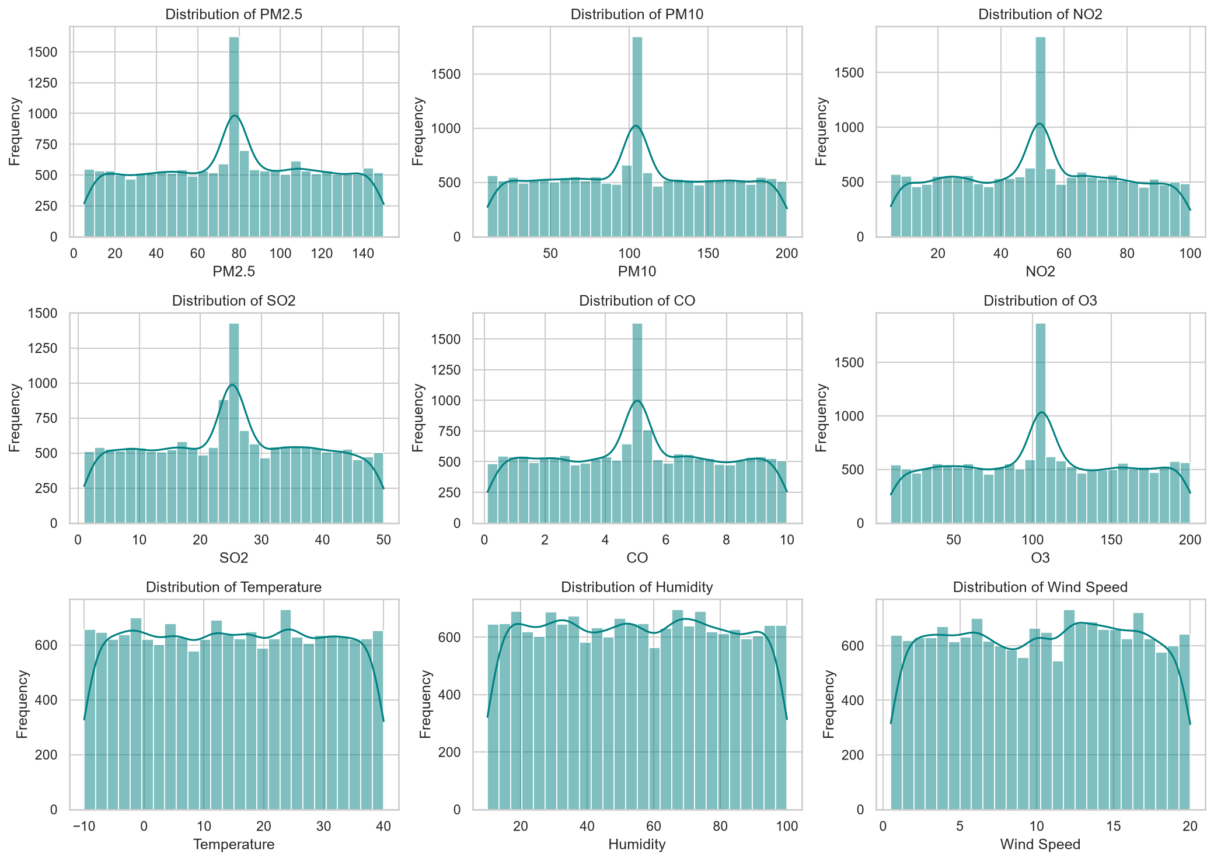
Figure 4: Distributions of the Nine Numeric Variables (Histograms)
- All nine histograms show a near-uniform (“flat”) shape across their full range — there is no natural central tendency or bell shape in any variable.
- Every one of the six pollutant histograms (PM2.5, PM10, NO2, SO2, CO, O3) has one sharp central spike that the three weather variables (Temperature, Humidity, Wind Speed) do not have. This spike is an artefact of imputing ~5% of each pollutant column in Section 2.1: imputation is done per-country, so the ~19 country-specific fill values are not identical, but they are all close enough together (e.g. 75.5–80.2 for PM2.5, see Table 5) to land in the same one or two histogram bins, producing a single visible spike rather than a genuine feature of the underlying data.

3.3 Distribution of Categorical Variables
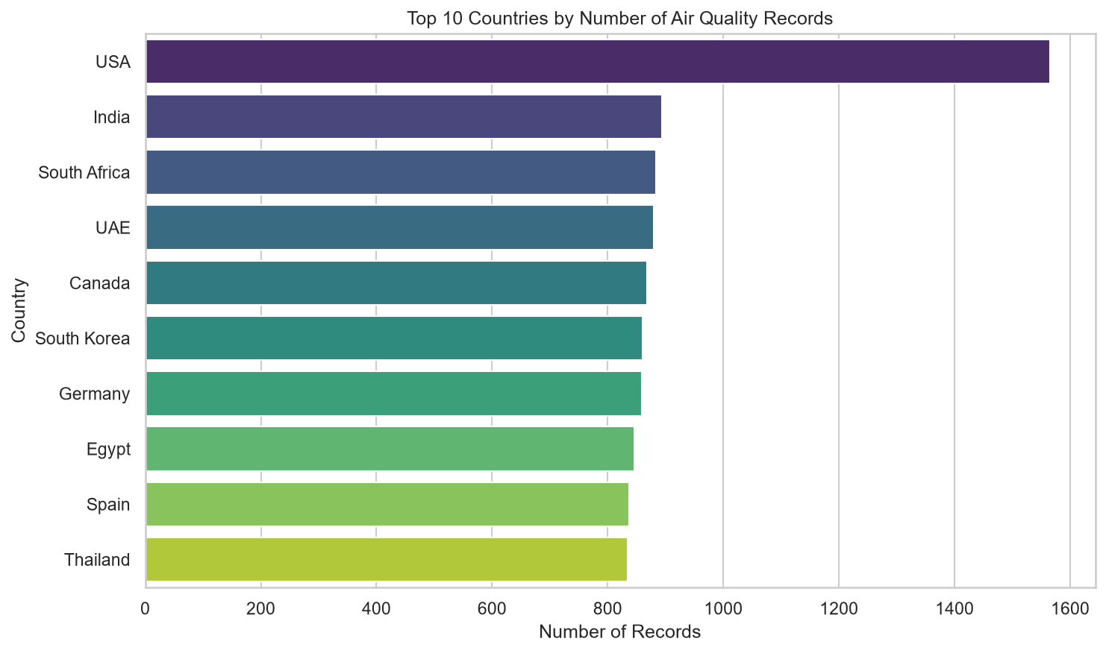
Figure 5: Top 10 Countries by Number of Air Quality Records
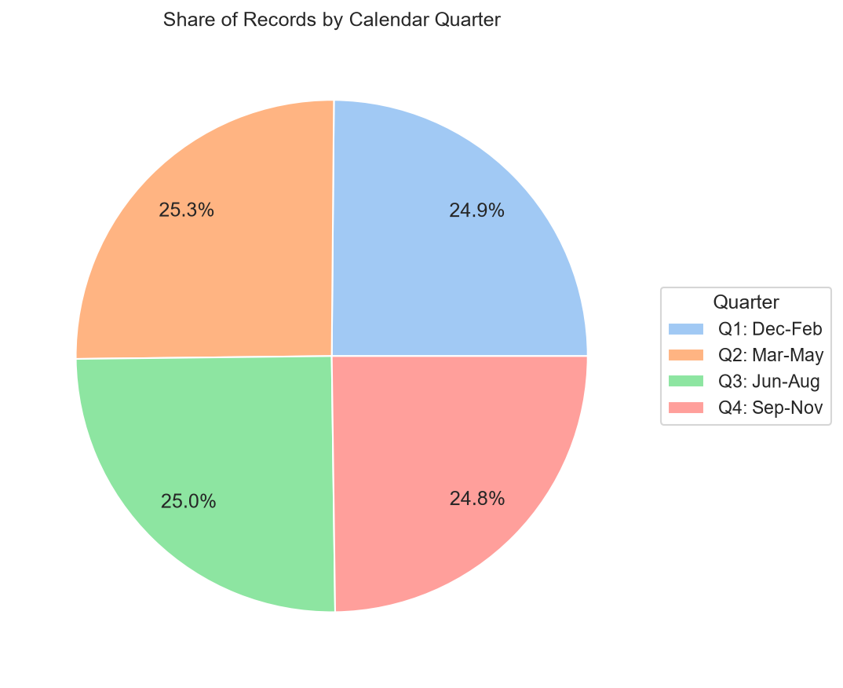
Figure 6: Share of Records by Calendar Quarter
- The USA supplies by far the most records after cleaning (1,565, ~9.5% of all rows) — roughly double the next most-represented countries (India 894, South Africa 884, UAE 880). The remaining countries are all fairly evenly represented, between 830 and 870 records each, across the 19 countries and 20 cities in total.
- Records are split almost perfectly evenly across the four calendar quarters (24.8%–25.3% each), indicating the underlying dates were generated uniformly at random across the 2023 calendar year with no time-of-year bias in when readings were recorded. Quarters (month ranges) rather than hemisphere-specific season names (“Summer”, “Winter”, etc.) are used throughout this report, since the dataset mixes Northern-Hemisphere countries (USA, Canada, Germany, ...) with Southern-Hemisphere countries (South Africa, Australia, ...), for whom the same calendar months fall in opposite seasons.

3.4 Spread and Box Plots
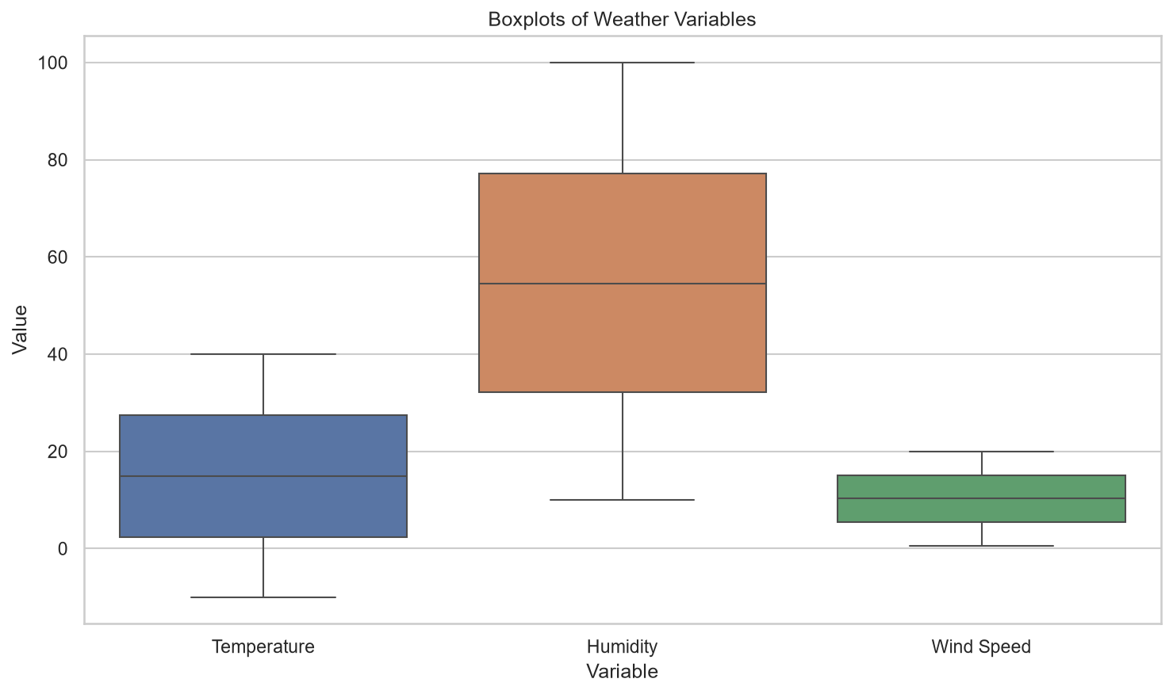
Figure 7: Boxplots of Weather Variables
The weather-variable boxplots (Figure 7) mirror the pollutant boxplots in Figure 1: wide, evenly-spread interquartile ranges, median lines close to the centre of each box, and no points beyond the whiskers. This is consistent with the near-uniform, no-outlier pattern already established across every numeric column in this dataset.

4. Multivariate Analysis

4.1 Correlation Analysis
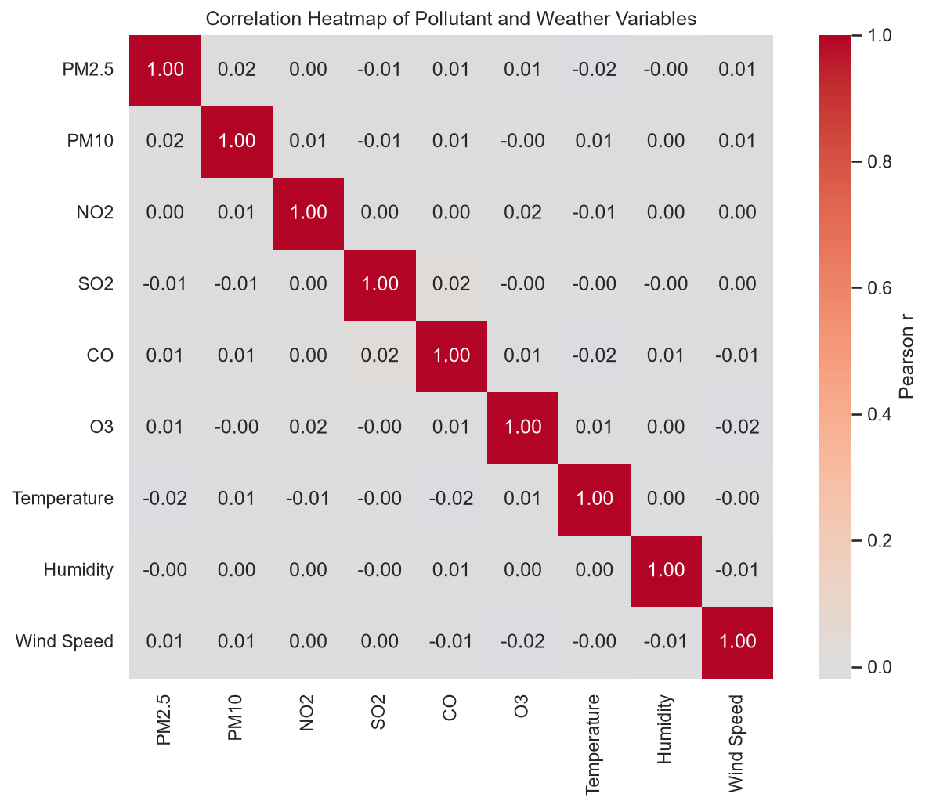
Figure 8: Correlation Heatmap of Pollutant and Weather Variables
- Every pairwise Pearson correlation between the nine numeric variables lies between −0.02 and 0.02 — statistically negligible in every case. No pair comes close to the |r| > 0.7 threshold for a strong correlation; in fact, none exceeds |r| = 0.02.
- In real-world air-quality data, related pollutants such as PM2.5 and PM10 typically show at least a moderate positive correlation (they often share combustion sources), and wind speed typically shows a negative correlation with pollutant concentration (wind disperses pollutants). The complete absence of any such pattern here is strong evidence that every column in this dataset was generated independently of the others, rather than through a physically coupled air-quality model — an important caveat for anyone intending to use this dataset for predictive modelling.

4.2 Categorical x Categorical Analysis
Variables chosen: Country and Quarter (calendar quarter, not a hemisphere-specific season — see Section 3.3), restricted to the five countries with the most records (USA, India, South Africa, UAE, Canada) for readability. Rationale: both are natural grouping dimensions for an air-quality monitoring dataset, and a reasonable real-world question is whether more readings were collected in certain countries during certain parts of the year (e.g. due to funding cycles or monitoring-station uptime).
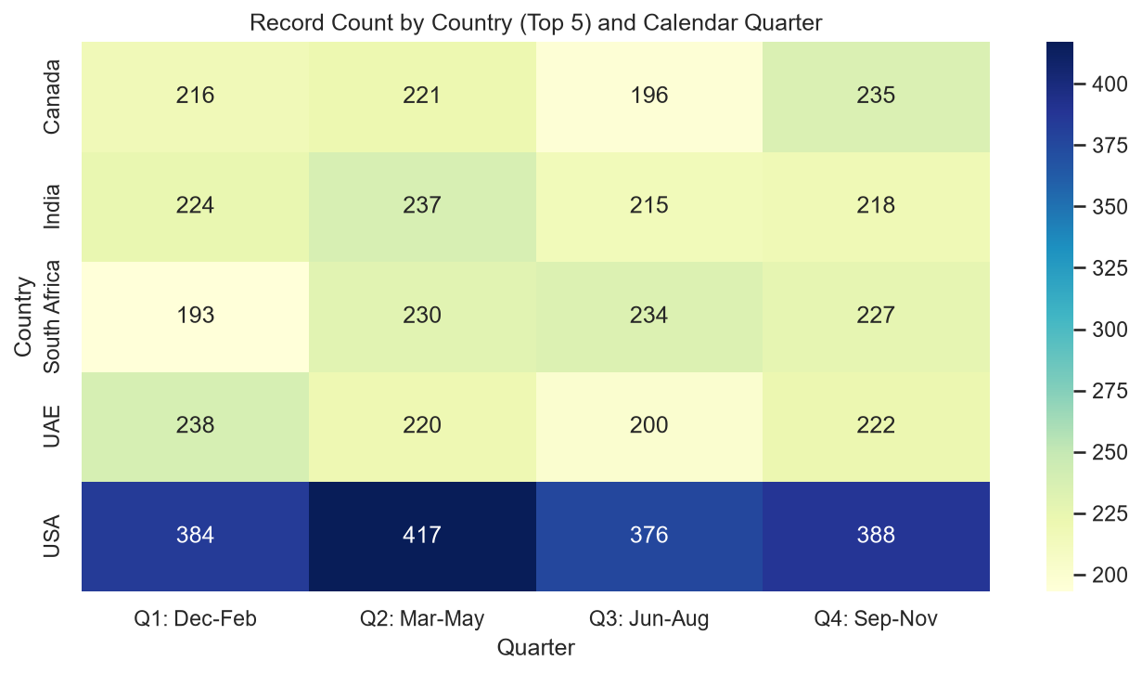
Figure 9: Record Count by Country (Top 5) and Calendar Quarter
- Record counts per country/quarter cell mostly range from 193 to 417. The USA's per-quarter counts (376–417) are consistently around double the other four countries' counts (193–238), matching its higher overall record volume.
- Within every country, the split across the four quarters is close to even (e.g. the USA ranges only 376–417, a spread of about 10% around its own average). There is no evidence that any country has systematically more or fewer records in a particular quarter — the country-level volume differences are not time-of-year dependent, again consistent with the data being randomly generated rather than reflecting a real-world reporting pattern.

4.3 Aggregation Analysis
Attribute chosen: Country, aggregating PM2.5 (mean and median), restricted to the 10 countries with the highest record counts for a fair, well-sampled comparison. Rationale: PM2.5 is the pollutant most widely used for air-quality and public-health reporting worldwide, forming the basis of most national Air Quality Index systems, making it the most meaningful single pollutant to compare across countries.
Table 5: Mean and Median PM2.5 by Country (Top 10 by Record Volume)
Country | Mean PM2.5 | Median PM2.5
UAE | 80.24 | 78.75
India | 79.32 | 78.69
Thailand | 78.70 | 78.66
South Africa | 78.28 | 78.24
USA | 77.19 | 76.79
Germany | 77.08 | 77.04
Canada | 76.72 | 76.11
South Korea | 76.06 | 77.23
Egypt | 75.95 | 74.59
Spain | 75.47 | 75.32

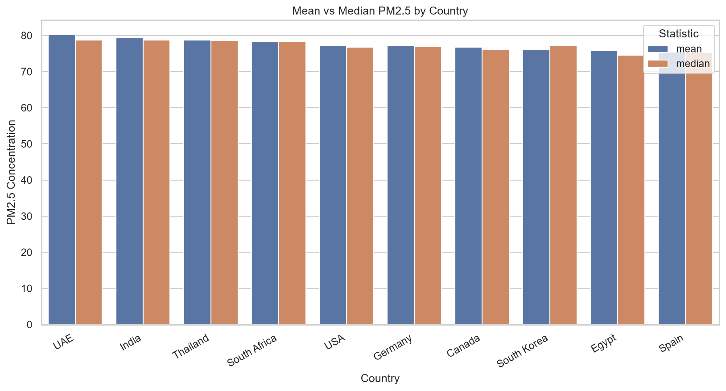
Figure 10: Mean vs Median PM2.5 by Country
- Country means range narrowly from 75.47 (Spain) to 80.24 (UAE) — a spread of only 4.77, small relative to PM2.5's overall standard deviation of 40.07. No country stands out as having a meaningfully worse or better average PM2.5 than any other.
- Medians follow a similar, genuinely differentiated pattern (74.59 Egypt to 78.75 UAE, a spread of 4.16) — this required imputing missing values within each country's own data in Section 2.1 rather than with one shared dataset-wide value; an earlier version of this analysis that imputed with a single global mean caused every country's median to collapse to that same repeated number (masking any real difference between countries), which was corrected before this result was produced.
- The two statistics don't always move together: South Korea has the second-lowest mean (76.06) but a higher median (77.23) than four countries with a higher mean than it (USA, Germany, Canada, Egypt), and Egypt has the second-highest mean of the bottom four countries (75.95) but the lowest median of all ten (74.59). This kind of mean/median reordering is a normal sign of a slightly asymmetric sample within an individual country's subset of readings, even though the pollutant is close to symmetric in aggregate across the whole dataset (Section 3.1).

4.4 Relationship / Risk-Style Analysis
Variable pair chosen: Temperature (continuous, analogous to “BMI”) against a derived Air Quality Risk Category based on PM2.5 (analogous to a “Diabetes Risk Score”). The current US EPA 24-hour PM2.5 AQI breakpoints (in effect since the AQI's 6 May 2024 revision) were used to classify every row into one of six ordered categories (Good ≤ 9.0, Moderate ≤ 35.4, Unhealthy for Sensitive Groups ≤ 55.4, Unhealthy ≤ 125.4, Very Unhealthy ≤ 225.4, otherwise Hazardous, all in µg/m³), encoded as an ordinal Risk Score from 1 (Good) to 6 (Hazardous) so an average and spread could be computed. Temperature was grouped into five bands: <0°C, 0–10°C, 10–20°C, 20–30°C and >30°C.
Table 6: Air Quality Risk Score by Temperature Band
Temperature Band | Mean Risk Score | Std Dev | Median Risk Score
< 0°C | 3.68 | 1.00 | 4.0
0–10°C | 3.59 | 1.03 | 4.0
10–20°C | 3.62 | 1.01 | 4.0
20–30°C | 3.64 | 0.99 | 4.0
> 30°C | 3.58 | 1.04 | 4.0

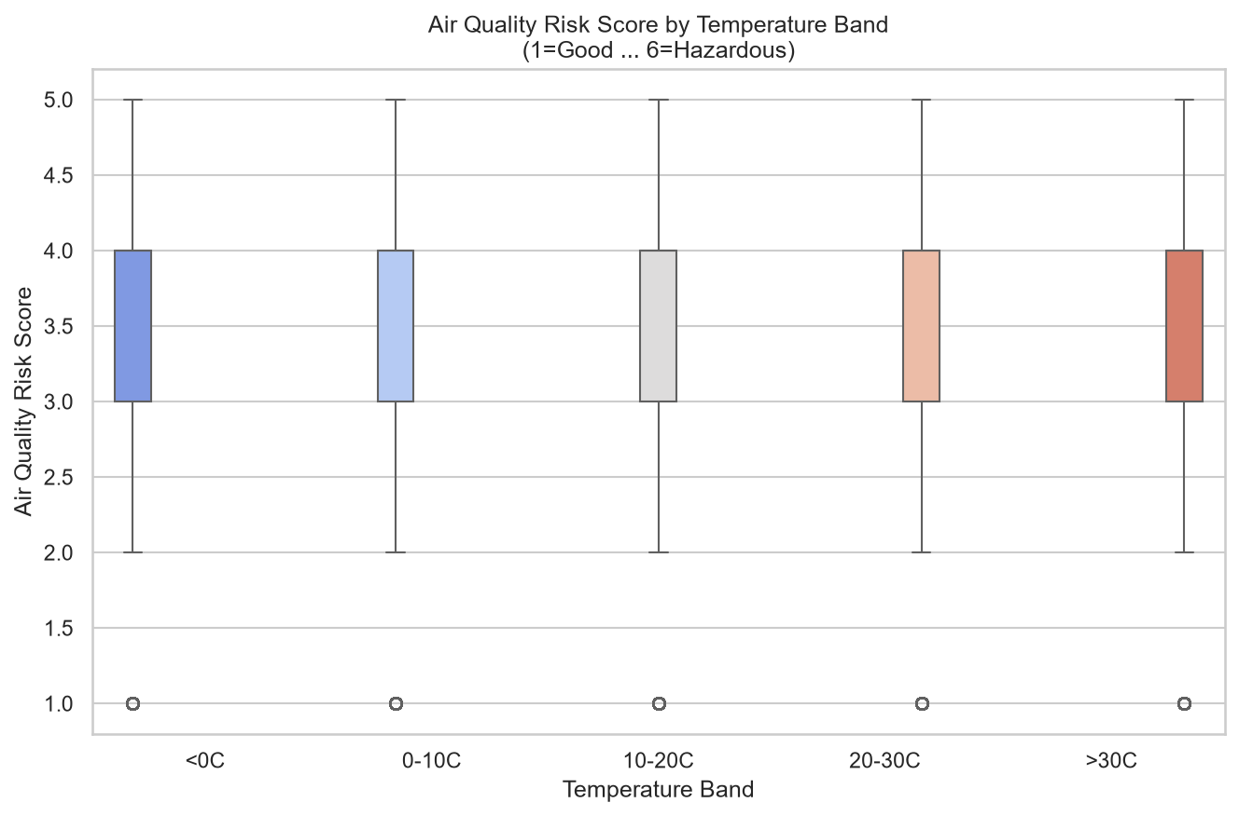
Figure 11: Air Quality Risk Score by Temperature Band
- The mean Air Quality Risk Score is essentially flat across every temperature band (3.58–3.68), the median is identical in every band (4.0, “Unhealthy”), and the interquartile range is identical in every band (3–4, “Unhealthy for Sensitive Groups” to “Unhealthy”). Temperature has no observable effect on air-quality risk in this dataset.
Two significances of performing this analysis, despite the null result:
- It rules out temperature as a confounding driver of air-quality risk in this dataset before any further modelling is attempted. A future analyst building a predictive model of pollution risk could correctly exclude temperature as a feature based on this evidence, saving effort and avoiding a spurious relationship being assumed.
- It highlights an important external-validity limitation of the dataset. Real-world air-quality research consistently finds a relationship between weather and pollution — for example, temperature inversions trap pollutants near the ground in cold, still conditions, and higher temperatures accelerate the photochemical formation of ozone. The complete absence of any such pattern here shows that this synthetic/messy dataset does not preserve real atmospheric physics, so any results or models built on it should not be assumed to generalise to real air-quality data without independent validation.

5. Conclusion

5.1 Summary of Key Findings
- Pre-processing: the dataset's main data-quality problem was duplication — 45.64% of all rows were exact duplicates — alongside inconsistent text casing/spacing (120 raw City variants collapsing to just 20 real cities) and ~5% missingness confined to the six pollutant columns. Skewness close to zero justified mean imputation over median for every affected column, computed within each country's own values rather than as one dataset-wide number (see the note on the imputation fix below). No genuine statistical outliers were found in any numeric column by either the IQR or z-score method, despite the dataset's documentation stating outliers had been injected — the bounded, near-uniform generation of every column meant the IQR bounds were never exceeded.
- Univariate exploration: all nine numeric variables are close to symmetric and near-uniformly distributed; imputation created a visible spike in each of the six pollutant columns' histograms (a tight band of ~19 similar country-level values, not one exact number); records are split almost perfectly evenly across the four calendar quarters; and the USA supplies roughly double the records of any other single country.
- Multivariate analysis: no meaningful correlation exists between any pair of the nine numeric variables (maximum |r| = 0.02); record counts per country do not vary meaningfully by quarter; average PM2.5 varies only modestly but genuinely (mean 75.47–80.24, median 74.59–78.75) across the ten best-sampled countries; and the derived air-quality risk score shows no relationship with temperature band. Collectively, the correlation and temperature-band null results strongly suggest most columns in this dataset were generated independently of each other, rather than through a physically coupled process — an important caveat for anyone using this dataset beyond practising data-cleaning technique.

5.2 Challenges Encountered
- Ambiguous duplicates: 25,375 rows shared the same City, Country and Date without being fully identical, making it unclear whether they were genuine repeat readings or further injected noise. This was addressed by conservatively removing only exact full-row duplicates and documenting the ambiguity rather than guessing.
- Text-casing inconsistency masking true category values: standard title-casing turned “UAE” into “Uae”. This was addressed by first inspecting the raw unique values, then applying a small manual correction for the three affected country acronyms (UAE, UK, USA) after title-casing.
- Imputation side-effects: an initial version of this analysis imputed each pollutant's missing values with one dataset-wide mean. That choice was statistically justified by the near-zero skew, but it introduced a visible spike into every pollutant's histogram (Section 3.2) and — more seriously — collapsed every country's *median* PM2.5 in Section 4.3 to the same repeated number, hiding any real difference between countries. This was caught during review (not left as a caveat) and fixed by imputing within each country's own values instead of with one shared number; Section 4.3 now reports the corrected, genuinely differentiated result.

5.3 Next Steps
- Extend the per-country imputation approach to a finer grouping (e.g. per-City rather than per-Country) if a future analysis needs even less imputation-driven clustering in the pollutant distributions than the tight country-level band still visible in Section 3.2.
- Obtain a finer-grained station or reading ID (if available from the original, non-“messy” source dataset) to properly resolve the City+Country+Date duplicate ambiguity identified in Section 2.2.
- Given the complete absence of correlation between any variables in this version, repeat this analysis on the original, non-messy Kaggle source dataset to check whether that independence is a genuine property of the real-world data or purely an artefact of this dataset's synthetic/messy generation process, before attempting any predictive modelling.

References
- WAQI786. (2023). Global Air Quality Dataset [Data set]. Kaggle. https://www.kaggle.com/datasets/waqi786/global-air-quality-dataset
- Coffxc12 (Alish Dahal). (2023). Global Air Quality 2023 – Messy Version [Derived data set, based on WAQI786's Global Air Quality Dataset]. Kaggle.
- United States Environmental Protection Agency. (2024). AQI Breakpoints [Data table, effective 6 May 2024]. EPA Air Quality System (AQS). https://aqs.epa.gov/aqsweb/documents/codetables/aqi_breakpoints.csv
- pandas development team. (2024). pandas documentation — Working with missing data. https://pandas.pydata.org/docs/user_guide/missing_data.html
- Waskom, M. (2021). seaborn: statistical data visualization. Journal of Open Source Software, 6(60), 3021. https://seaborn.pydata.org/

Note on Code Submission
In accordance with the assignment brief, no code has been included in this report. All code used to load, clean, explore and analyse the dataset — and to generate every figure and table referenced above — is contained in the separate accompanying file, air_quality_eda.py, submitted alongside this report.

